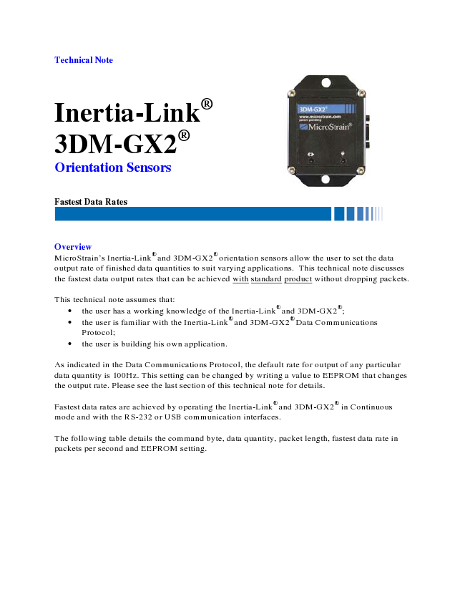
Technical Note
Inertia-Link® 3DM-GX2® Orientation Sensors
Fastest Data Rates
Overview MicroStrain’s Inertia-Link® and 3DM-GX2® orientation sensors allow the user to set the data output rate of finished data quantities to suit varying applications. This technical note discusses the fastest data output rates that can be achieved with standard product without dropping packets.
This technical note assumes that:
• the user has a working knowledge of the Inertia-Link
®
and 3DM-GX2
®
;
• the user is familiar with the Inertia-Link
®
and 3DM-GX2
®
Data Communications Protocol;
• the user is building his own application.
As indicated in the Data Communications Protocol, the default rate for output of any particular data quantity is 100Hz. This setting can be changed by writing a value to EEPROM that changes the output rate. Please see the last section of this technical note for details.
Fastest data rates are achieved by operating the Inertia-Link® and 3DM-GX2® in Continuous mode and with the RS-232 or USB communication interfaces.
The following table details the command byte, data quantity, packet length, fastest data rate in packets per second and EEPROM setting.
Fastest Data Rates
Command Data Packet
Data Rate
in EEPROM
Byte Quantities Length
Packets/
Second Setting
0xC1
Raw Accelerometer and Angular Rate Sensors Outputs 31 187 274 0xC2 Acceleration and Angular Rate 31 187 274 0xC3 DeltaAngle and Delta Velocity 31 187 274 0xC5 Orientation Matrix 43 156 328 0xC6 Attitude Update Matrix 43 156 328 0xC7 Magnetometer Vector 19 237 216
0xC8
Acceleration, Angular Rate and Orientation Matrix 67 115 445
0xCB
Acceleration, Angular Rate and Magnetometer Vector 43 155 330
0xCC
Accel, Ang Rate, Mag Vectors and Orientation Matrix 79 102 502 0xCE Euler Angles 19 218 235 0xCF Euler Angles and Angular Rates 31 180 284
0xD2
Gyro Stabilized Acceleration, Angular Rate and Magnetometer Vector 43 155 330
0xD3
DeltaAngle, Delta Velocity and Magnetometer Vectors 43 155 330
Important Notes
• The rates are NOT valid for any standard Inertia-Link® or 3DM-GX2® with 2.4 GHz wireless interface; expect rates topping out at ~100 Hz.
• The rates are NOT valid for any OEM Inertia-Link
®
or 3DM-GX2
®
; rates up to 1000Hz can be achieved. Please contact MicroStrain for OEM configurations.
• The rates are NOT valid for any custom Inertia-Link® or 3DM-GX2® with RS-232 or USB interface with baud rates above 115.2 Kbaud; higher rates can be achieved with higher baud rates. Please contact MicroStrain for custom configurations.
Calculation Cycle and Data Output Rate The on-board processor of the Inertia-Link® or 3DM-GX2® continuously executes a calculation cycle. The steps in this cycle include the following:
1. Convert raw sensor outputs into digital form 2. Scale sensor outputs into physical units (including temperature, alignment, and G-
sensitivity compensation). 3. Propagate and filter the orientation estimate. 4. If host has issued a command byte (or if operating in continuous mode), compute
appropriate response data and transmit.
Step 4 in this cycle is only executed if the Inertia-Link® or 3DM-GX2® has received a command byte from the host (or if the device is in continuous mode).
Fastest Data Rates
The calculation cycle continuously repeats itself (even if no data is requested by the host). The time required to complete a calculation cycle determines the fundamental limit on the maximum data output rate. Generally, only one new data record can be generated and output for each calculation cycle.
The duration of each calculation cycle is determined by the internal clock in combination with an adjustable divider
CalcPeriod =
51200 x
Where
CalcPeriod = duration of the calculation cycle in seconds x = divider constant
The maximum Data Output Rate is the inverse of CalcPeriod
DataRate
=
51200 x Where
DataRate = maximum data output rate in Hertz x = divider constant
DataRate quantifies the rate at which data records will be generated when running in continuous mode. In polled mode, this rate can also be achieved if the host program is capable of sending requests for data at a rate equal to or greater than the DataRate.
The factory default value of x is 512 giving a default data rate of 100Hz. x is stored as a 16 bit unsigned integer value in EEPROM address 0xFCA2. The value of x can be changed by utilizing the Write Word to EEPROM command. Valid values are within the range of 51200 (1Hz) to 170 (~300Hz).
MicroStrain, Inc. 310 Hurricane Lane, Unit 4 ph: 800-449-3878 Williston, VT 05495 USA fax: 802-863-4093 Copyright © 2008 MicroStrain, Inc. www.microstrain.com support@microstrain.com
H Micr0Strain'

